400 W AC Servo Motor 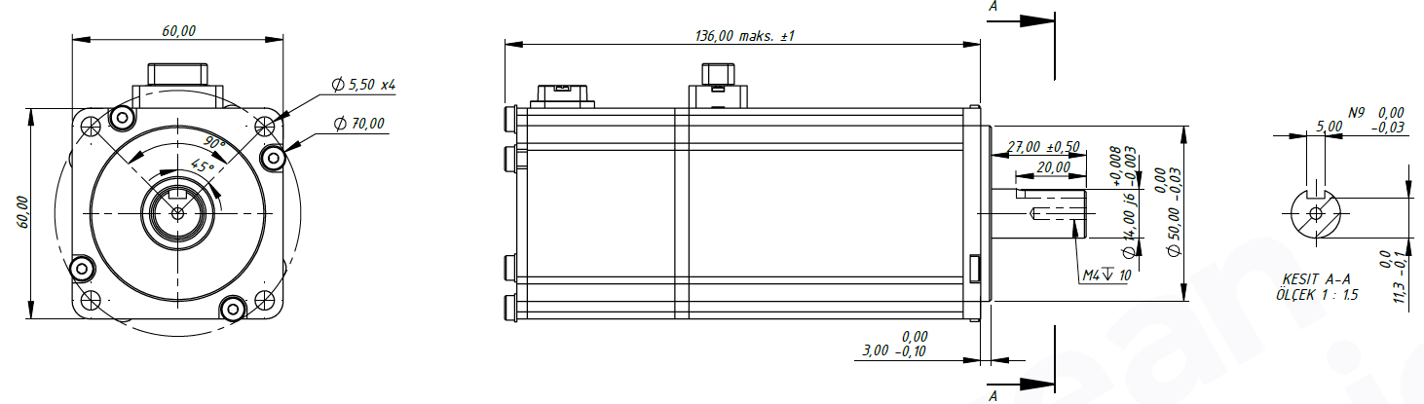
Basic Motor Parameters
Rated Power | W | 400
Rated Speed | rpm | 3000
Rated Torque | Nm | 1.27
Rated Current | A | 2.5
Rated Voltage | V | 220
No-Load Speed | rpm | 3000
Max. Efficiency | % | 90
Electrical Parameters
Number of Phases |  | 3
Number of Poles |  | 10
Torque Constant (KT) | Nm/A | 0.809
Back EMF Constant (KE) | Vs/rad | 0.66
Terminal Resistance Phase to Phase (±%10) | mΩ | 2750
Terminal Inductance Phase to Phase (±%30) | mH | 30
Thermal Data
Ambient Temperature | °C | -40...+85
Max. Winding Temperature | °C | +155
Physical Parameters
Outer Diameter | mm | 60x60 (Square)
Shaft Diameter | mm | 14
Max. Lenght | mm | 136
Weight | gr | ~1207
Motor Connection
U | GREY
V | BROWN
W | BLACK
Sensor Connection
Vcc (+5VDC) | RED
GND | BLACK
GND | BROWN/BLACK
VB | BROWN
SD | BLUE
SD | BLUE/BLACK
BODY GND | GREY
SCREEN | -
CHASSİS | -
Connector Articles
Power | CONNECTOR SERVO SOCKET 4P
Signal | CONNECTOR SERVO SOCKET 9P

